SOP for Federated EGA Helpdesk - Impersonate a FEGA user

Document Owner | Aina Jené - EGA-CRG Operations Manager
Version | 1.0
Effective date | 31-05-2023

Purpose
Once you have set up your FEGA Helpdesk Portal, you can impersonate a user and login as that user without sharing credentials. This is most useful when a user reports an issue with their submission or with managing their data requests, and you can check their portal without sharing passwords. If you don’t know how to get access to your FEGA Helpdesk node for the first time, please follow this SOP.

Scope
Once you have set up your FEGA Helpdesk Portal, you can impersonate a user and login as that user without sharing credentials.

Procedure
- Log in to your FEGA Helpdesk Portal (helpdesk.{fega}.ega-archive.org) with your credentials (you must be in the helpdesk group). Check this SOP if you want to gain access for the first time. Or this SOP if you already have an admin and would like to add more people.
- Once you are logged in go to IMPERSONATE
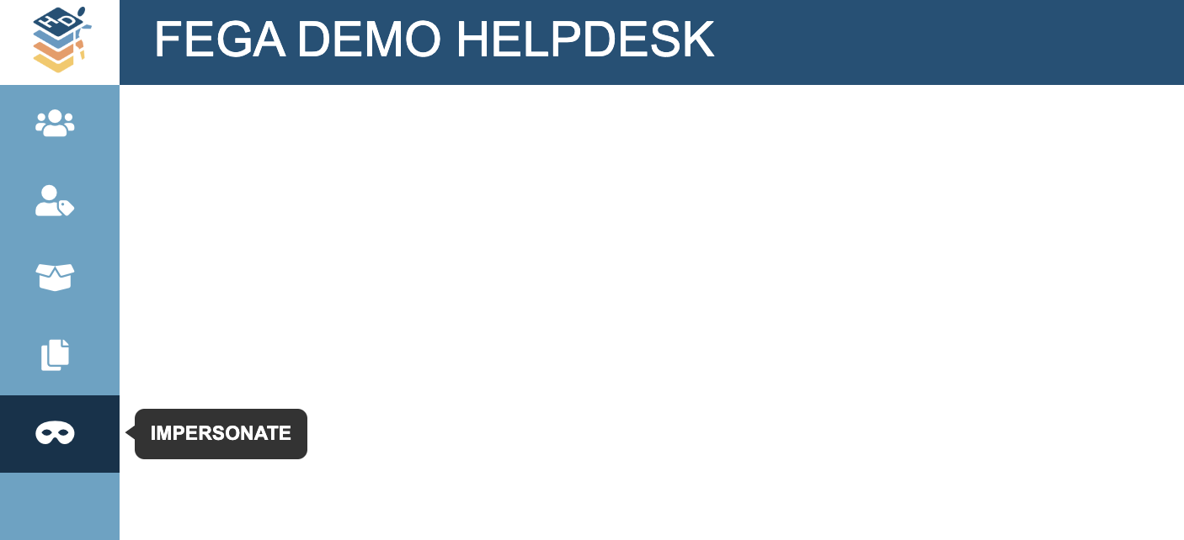
- Type the full length of the username or email of the FEGA user you want to check and select it from the drop-down menu
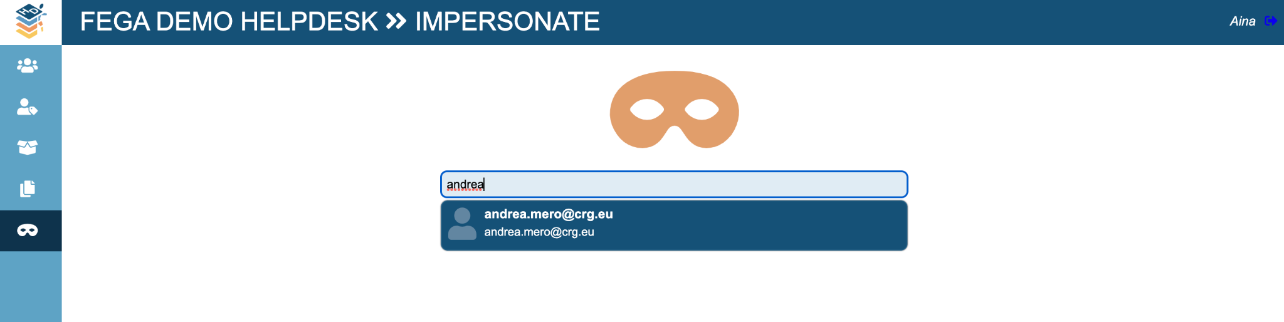
- You will immediately obtain a token to impersonate the FEGA user.
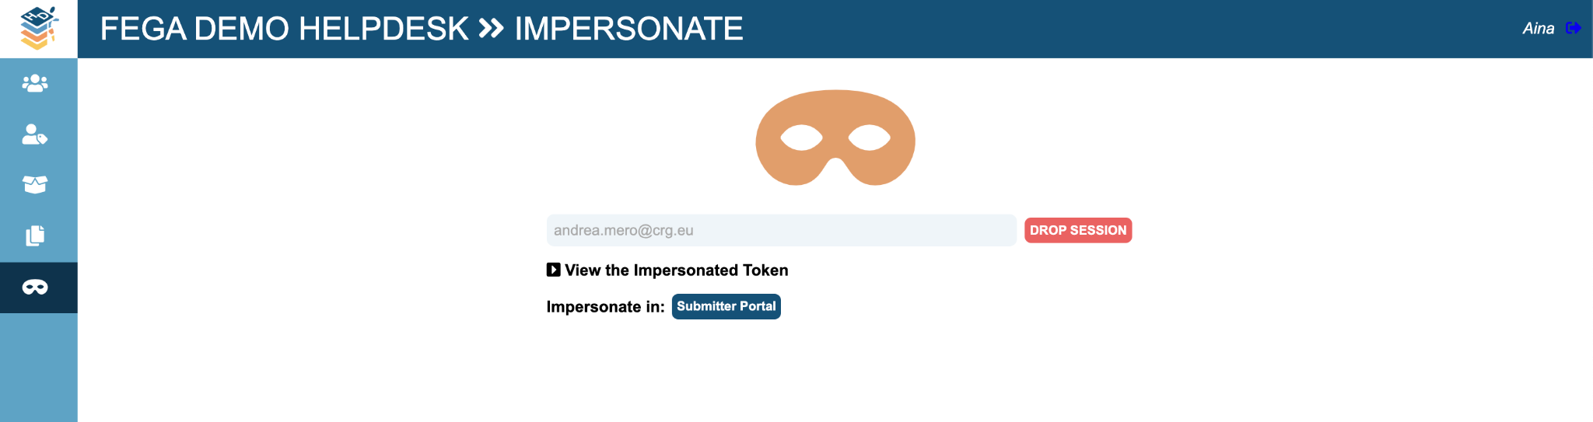
  - You can also check the token by clicking on “View the impersonated Token”
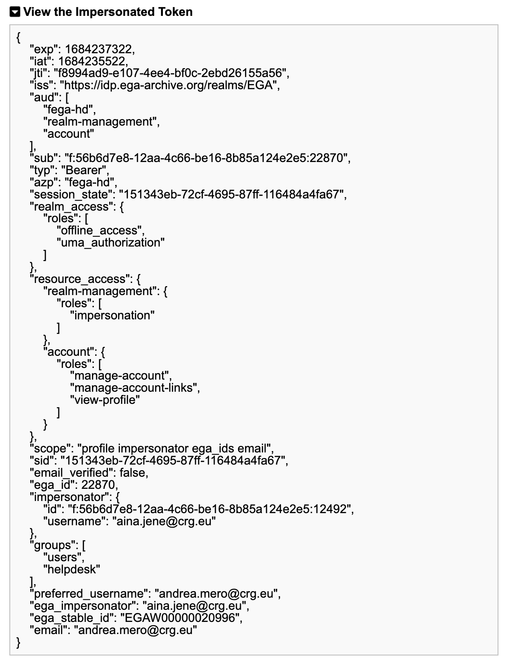
- Once you are impersonating the user, you will see the different roles that user is assigned to, and find a direct link to the portal they are using. In this case, this user is a submitter and can only impersonate the user in the Submitter Portal.
- Click DROP SESSION whenever you want to stop impersonating the user.

